**Increment & Decrement Operators**

Increment and Decrement Operators are unary operators used to increment or decrement a **variable** value by 1.

**Note:** ++ and – operators are only use with **variables**, if it uses with value like: 6++ or 4— **Error** will occurs.

* Increment Operator (++) is used to increment a variable value by 1.
* Decrement Operator (--) is used to decrement a variable value by 1

|  |  |
| --- | --- |
| **Types of Increment Operator (++)** | **Types of Decrement Operator (--)** |
| **Post Increment** 🡺 variableName **++** | **Post Decrement** 🡺 variableName **--** |
| **Pre Increment** 🡺 **++** variableName | **Pre Decrement** 🡺 **--** variableName |

**Example 1:**

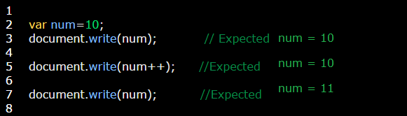

**Illustration:**

**num++** operator will be first split to **num** variable and **++** operator. Then **++** part will down to the next line whereas **num** variable will stay at his place. Like in this screen:

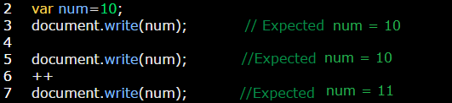

**Example 2:**

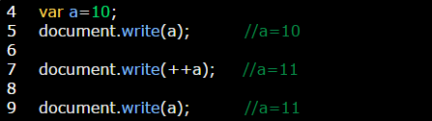

**Illustration:**

**++a** operator will be first split to ++ variable and **a** operator. Then **++** part will down to the next line whereas **a** variable will stay at his place. Like in this screen:

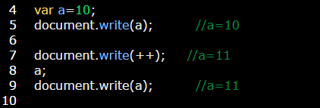

**Example 3:**

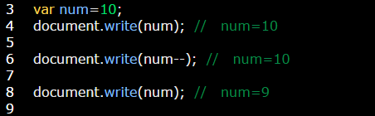

**Illustration:**

**num--** operator will be first split to **num** variable and **--** operator. Then **--** part will down to the next line whereas **num** variable will stay at his place. Like in this screen:

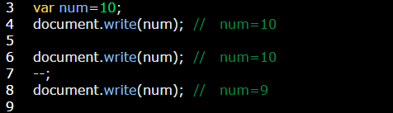

**Example 4:**

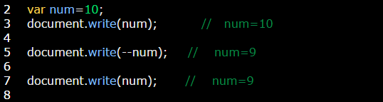

**Illustration:**

**--num** operator will be first split to **--** variable and **num** operator. Then **num** part will down to the next line whereas **--** variable will stay at his place. Like in this screen:

